

##### AACS1483 Web Design and Development

**Assignment**

**Year 2022/2023, Semester 1**

| **Programme : DFT1S1** | |
| --- | --- |
| **Tutorial Class : G17** | |
| **Website Title : Tea Why Cafe** | |
| | **No.** | **Student Name** | **Student ID** | **Module In Charge** | **Signature** | **Part 1**  **(30%)** | **Part 2**  **(70%)** | **Total**  **(100%)** | | --- | --- | --- | --- | --- | --- | --- | --- | | **1** | **Chia Ming Yi** | **22WMD08132** | **Home, Food & Beverage, Events, About us, Sign/Login** | **MingYi** |  |  |  | | **2** | **Ng Zi Cheng** | **22WMD08043** | **Home, Our Features**  **, About us, Sign/Login** | **ZiCheng** |  |  |  | | **3** | **Chan Mun Wai** | **22WMD08** | **Find us, Help, Our Features** | **MunWai** |  |  |  | | **4** | **Fong Chan Hins** | **22WMD08** | **Find us, Help** | **ChanHins** |  |  |  | | **5** | **Chu Jin Her** | **22WMD08** | **Find us, Help** | **JinHer** |  |  |  | | |
| **Lecturer: Tan Lai Kien** | **Practical Tutor : Pang Yik Siang** |
| **Date of Submission: 2/10/2022** | |

**Assignment: Use web development tool, HTML, Cascading Style Sheets (CSS) and JavaScript to create a website for conducting the business online and fulfilling the customer needs.**

**Assessment Rubrics – Assignment Part 1 (30 marks)**

| Proposal -**Criteria** | **Marks** | **Excellent** | **Good** | **Average** | **Poor** | **Score** |
| --- | --- | --- | --- | --- | --- | --- |
| **CLO 3: Develop websites to cater for different types of products or services in the business world. (A2, PLO7)** | | | | | | |
| Planning   * Description of the organization * Website objectives * Potential users * Information the users need * Proposed deliverable | 15 | Excellently define all the required information.  (12 –15) | Correctly define most of the required information.  (9 – 11) | Correctly define some of the information. The rest are either incorrect or missing.  (6 – 8) | Most of the information is missing, incomplete or incorrect.  (0 – 5) |  |
| Web Analysis   * Functions or modules | 15 | Excellently define all the required information.  (12 –15) | Correctly define most of the required information.  (9– 11) | Correctly define some of the information. The rest are either incorrect or missing.  (6 – 8) | Most of the information is missing, incomplete or incorrect.  (0 –5) | | Name | Mark | | --- | --- | | 1.Chia Ming Yi |  | | 2.Ng Zi Cheng |  | | 3.Chan Mun Wai |  | | 4.Fong Chan Hins |  | | 5.Chu Jin Her |  | |  |  | |
| **Total (30 marks)**  Comments (if any):  _____________________________________________________________________________________________________________________________________________________________________________________________________________________________________________________________________________________________________________________________________________________________________________________________________________________________________________________________ | | | | | | | Name | Mark | | --- | --- | | 1.Chia Ming Yi |  | | 2.Ng Zi Cheng |  | | 3.Chan Mun Wai |  | | 4.Fong Chan Hins |  | | 5.Chu Jin Her |  | |  |  | |

**Assessment Rubrics – Assignment Part 2 (70 marks)**

| **Criteria** | **Marks** | **Excellent** | **Good** | **Average** | **Poor** | | **Score** | |
| --- | --- | --- | --- | --- | --- | --- | --- | --- |
| **CLO 2: Demonstrate the web development using web development tool, Cascading Style Sheets (CSS) and JavaScript.** | | | | | | | | |
| **Functionality & Complexity of the Website Module using the following elements:**   * Media elements (text, graphic, audio, video and animation) * Hypertext and hypermedia * List * Formatting * Hotspot / image map * Table * Form * CSS for all of the GUI design (use External Style Sheet effectively) * JavaScript | **40** | Excellently completed more than 80% of the required functionalities correctly using all the listed elements. High level of complex algorithms and programming skills.  (32 – 40) | Completed more than 60% of the required functionalities correctly using most of the listed elements. Average level of complex algorithms and programming skills.  (21 – 31) | Averagely completed more than 40% of the required functionalities with some minor errors. Only used some of the listed elements.  Low level of complex algorithms and programming skills.  (11– 20) | Not able to complete most of the required functionalities correctly. Only used few of the listed elements.  Poor level of complex algorithms and programming skills.  (0 –10) | |  | |
| **Creativity in Modules’ Function & Interface Design** | **10** | Excellent creativity in module function and interface design.  (9 – 10) | Good creativity in module function and interface design.  (7 –8) | Average creativity in module function and interface design.  (5 – 6) | Poor creativity in module function and interface design.  (0 – 4) | | | Name | Mark | | --- | --- | | 1.Chia Ming Yi |  | | 2.Ng Zi Cheng |  | | 3.Chan Mun Wai |  | | 4.Fong Chan Hins |  | | 5.Chu Jin Her |  | | |
| **User Interface Features** | **20** | Excellent design consistency and interface usability, visual effect and interactivity.  (16-20) | Good design consistency and interface usability, visual effect and interactivity.  (11-15) | Average design consistency and interface usability, visual effect and interactivity.  (6-10) | Poor design consistency and interface usability, visual effect and interactivity.  (0 – 5) | | | Name | Mark | | --- | --- | | 1.Chia Ming Yi |  | | 2.Ng Zi Cheng |  | | 3.Chan Mun Wai |  | | 4.Fong Chan Hins |  | | 5.Chu Jin Her |  | | |
| **Total (70 marks)**  Comments (if any):  **________________________________________________________________________________________________________________________________________________________________________________________________________________________________________________________________________________________________________________________________________________________________________________________________________________________________________________________________________________________________________________________________________** | | | | | | | Name | **Total** Mark | | --- | --- | | 1.Chia Ming Yi |  | | 2.Ng Zi Cheng |  | | 3.Chan Mun Wai |  | | 4.Fong Chan Hins |  | | 5.Chu Jin Her |  | | |

**Plagiarism Statement**

The university college views cases of plagiarism or collusion by students very seriously. Any students who intentionally plagiarize or collude in any part of their assignments/projects or written work threatens the values of academic work and undermines the credibility and integrity of the University College’s awards. Plagiarism or collusion discovered at any stage of the student’s course of study will be dealt with appropriately by the School. Such offender shall appear before a panel of enquiry at the School and appropriate punishment will be meted out. Punishment may include failing the student for the assignment or project, re-submission of another piece of work or downgrading the work to the maximum of a pass grade even if the actual grade achieved was higher.

**What constitutes “Plagiarism” and “Collusion”?**

Plagiarism according to the Oxford Advanced Learner’s Dictionary of Current English means “take and use somebody else’s ideas, words, etc. as if they were one’s own.”

**Plagiarism** can take the form of reproduction without acknowledgement from published or unpublished works of others including materials downloaded from computer files on the Interne.

Student’s work submitted for assessment is accepted on understanding that it is the students’ own effort without falsification of any kind. Acknowledgement to the source must be made if students had replied on any sources for information with appropriate reference being made in their work.

**Collusion** can be deemed to be a form of plagiarism involving the unauthorized co-operation between two or more people with deceptive intention.

Collusion can take the form of two or more students producing a piece of work together but one intentionally passing it off as his work with the knowledge of the others. Student may have submitted the work of another as his own with consent from that other student. In such cases, both parties are guilty of collusion.

**Obligations of students**

Students are required to sign a declaration that the work submitted such as coursework assignment, essays and projects, etc. is their own work and that they have not in any way knowingly allowed another student to copy it. It will be assumed that all submitted work is that of the students’ own work.

Students are expected to familiarize themselves with or make use of method(s) of citing other people’s work in accordance with acceptable referencing



**AACS1483 Web Design and Development**

**Plagiarism Statement Form**

**We confirm that the submitted works are all our own work and are in our own words.**

|  | **Name (Block Capitals)** |  | **Student ID** |  | **Signature** |
| --- | --- | --- | --- | --- | --- |
| **1.** | **CHIA MING YI** |  | **22WMD08132** |  | **MINGYI** |
| **2.** | **NG ZI CHENG** |  | **22WMD08043** |  | **ZICHENG** |
| **3.** | **CHAN MUN WAI** |  | **22WMD07860** |  | **MUNWAI** |
| **4.** | **FONG CHAN HINS** |  | **22WMD08006** |  | **CHANHINS** |
| **5.** | **CHU JIN HER** |  | **22WMD08028** |  | **JINHER** |

| **Tutorial Group :** | 17 |
| --- | --- |
| **Date :** | 2/10/2022 |

**Description of the organization**

Tea Why is a small company dedicated to the Tea Why Cafe that is loved by many due to its unique meals and beverages. Ever since 2018, our company has been pouring more and more effort in order to ensure that our customers have a delightful experience in the cafe.

In the Tea Why Cafe website, we have made sure to put in as much effort as we did with the cafe as a token of appreciation towards all our customers.As such, the website has all kinds of information on events where all our customers may take part in.

We have also made sure that there is a clear menu for our customers to decide on what they may want to eat.This way, if our customer is in a hurry, they may still take a look at our menu which would allow them to make up their mind by checking the menu online.

Our website is also newcomer friendly to make sure they are able to know the ins and outs of the cafe. This is said so as there’s a FAQ section of the website listing all the questions they may ask as well as answers.

All in all, the Tea Why Cafe website is made specifically to make our cafe even more accessible to people, as such we are able to receive more feedback on how to improve on anything we may be lacking.

**Website objectives** (Justifications/reasons for developing the website)

The Tea Why Cafe website is made to allow our customers to get information about all our newest events and products that may interest them. This will allow them to be prepared for partaking in each of the events. On top of that, if they have any inquiry about any of the events, they may easily access our website so they won’t have to wait in line just to ask several questions.

Alternatively, we also made the website to promote our cafe as we could only do so with posters and some advertisements on the bulletin board. These proved to be quite ineffective as we may only inform our customers about events coming soon and not everyone else in the world.And so, to extend our availability to everyone that may be interested to come by the cafe, we decided to make ourselves a website.This way, our customers can also help us promote our cafe to their friends and families with ease.

**Potential users of the website**

All the customers of Tea Why Cafe will be our focus as potential users for our website as they are the ones who have their most cherished memories with us at the Tea Why Cafe.

Now with the Tea Why Cafe website,they will be able to share their memories with their loved ones and also help promote us at the same time.

On top of that, we could also see new customers that would like to explore more of our cafe to be another potential user.They will be able to take a look at our menu and prices and even check out events that they may like.This way, we can also gain new customers in the cafe,who would be able to share their precious memories with their friends and family.

Furthermore,we think that any user that may be interested in visiting our cafe can also be a potential user as they may see something they like from the website.This is said so because our website is not just limited to our customers as it is for everyone that would want to give it a try.

**Information the users need and want**

Our user will be able to receive information on our menu and what they look like, through the photos that were used for reference, and also their prices as listed. They can also check out some examples of events and products that they could purchase on the menu page.

They will also be able to check out our ongoing events from the events tab given in the website. This will allow them to get ready or notified about the event so they won’t miss out on a thing.

Besides that, our customers will be able to look for help on the help page where all kinds of frequently asked questions are listed and answered so they may have an easier time using our website.

Nevertheless, they can also check out our contact numbers if there is any inquiry that they would like to make. This can be found on the about us page. This way, we will be able to communicate better with our customers as a whole.

**Proposed deliverable of the final website**

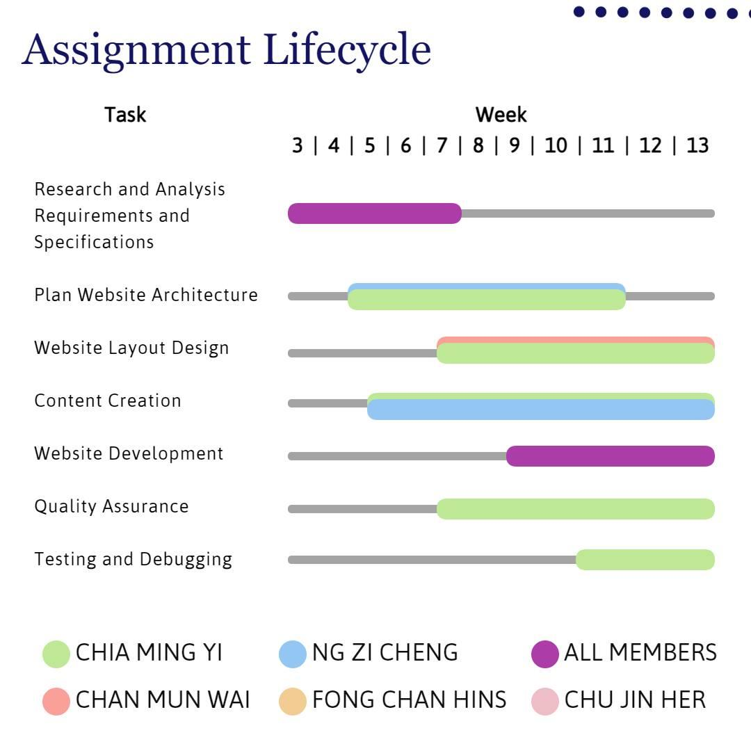

**Part 1 Chapter 2 Web Analysis**

* **Homepage**

**Is the first page that will display an advertisement video that will show all**

**kinds of beverages that are available at our Tea Why Cafe. There will be some text at the bottom which we think may pique some customer’s interest,especially new customers. Of course, there will also be music for our customers to listen to while they are waiting in line.**

* **Food & Beverage, Our Menu**

**The page where customers may take a look at our menu and make up their mind on what they may be purchasing. The menus are split into two parts so the customers do not have to worry about orders. There will be a lot of images for each and every product along with names and prices. The images will help customers differentiate between each product easily. On top of that, there will also be an advertisement related to our cafe for our customers to feel more immersed with the cafe.**

* **Our Features**

**The page which will display the ingredients used for our products to show that we use genuine ingredients to make our products.**

* **Events**

**Is the page where all kinds of events including the discounts and free gifts in the form of cakes and such are displayed. The event tab on the right will allow customers to navigate between each event for details they may not want to overlook. The events will be automatically alternate between one another.**

* **Find Us**

**Is the page that shows our customers where the closest store to their location is at. This allows our cafe to be more accessible by many customers who may not know where our cafe is located.**

* **About Us**

**Is the page where we introduce our company and cafe’s backstory as well as its ups and downs. There will also be a special announcement for the cafe on this page.**

* **Help**

**Is the page where customers may post questions for us to answer as well as some FAQs listed down for customer’s references. Customers may also give their feedbacks for the cafe to improve in the box given in this page.**

* **Sign/Log In**

**Is the page our customers may register for a new account or sign in to their current account.**

**References:**

<https://www.youtube.com/watch?v=IUmYJe8JPLU&ab_channel=FredrickBelarmino>

<https://domecafe.com.my/about/>

<https://www.the-alley.my/>

<https://www.facebook.com/teawhycafe/>

<https://sorellacafe.geniuspos.com.my/>

<https://www.brewshotcafe.com/>

<https://lifecafe.my/>

<https://poppykat.cafe/>

<https://zuscoffee.com/our-story/>

<https://sorellacafe.online/collections/>

<https://blackhorsemalaysia.com/>

<https://pixlr.com/cn/>

<https://zhuanlan.zhihu.com/p/36541501>

<https://www.w3schools.com/html/default.asp>

<https://www.w3schools.com/css/default.asp>

<https://www.w3schools.com/js/default.asp>

<https://pngtree.com/>

<https://www.zhihu.com/question/59892678>

<https://juejin.cn/post/6978469579508940831>